Revit_VSTA_Samples.rvt
Revit_VSTA_Samples.rvt can be opened by Revit Architecture, Revit Structure and Revit MEP. There are simple and common document-level macro samples included (15 C# sample macros and 15 VB.Net sample macros).
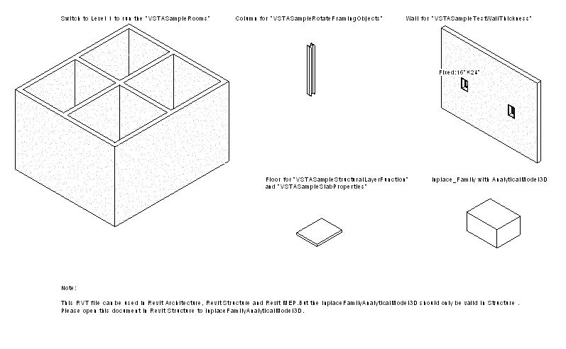
Figure 1: Revit_VSTA_Samples.rvt

C# Samples:
Sample Type | Sample Macro Name | Notes
Simple Samples | VSTASampleQuickPrint_FloorPlans  VSTASampleQuickPrint_Elevations  VSTASampleQuickPrint_Section
Simple Samples | VSTASampleFindAndReplaceText
Simple Samples | VSTASampleCapitalizeText
Simple Samples | VSTASampleFindAndReplaceWinType
Simple Samples | VSTASampleDeleteObject
Simple Samples | VSTASampleProjectInfo
Common Samples | VSTASampleCreateBeamsColumnsBraces
Common Samples | VSTASampleGridCreation
Common Samples | VSTASampleInplaceFamilyAnalyticalModel3D | Revit Structure only
Common Samples | VSTASampleRooms | Not available for Revit Structure
Common Samples | VSTASampleRotateFramingObjects
Common Samples | VSTASampleSlabProperties
Common Samples | VSTASampleStructuralLayerFunction
Table 1: Revit VSTA Samples in C#

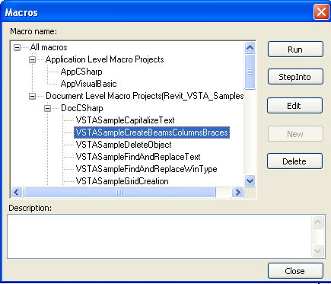
Figure 2: Revit VSTA Samples in C#

VB.Net Samples:
Sample Type | Sample Macro Name | Others
Simple Samples | VSTASampleQuickPrint_FloorPlans  VSTASampleQuickPrint_Elevations  VSTASampleQuickPrint_Section
Simple Samples | VSTASampleFindAndReplaceText
Simple Samples | VSTASampleCapitalizeText
Simple Samples | VSTASampleFindAndReplaceWinType
Simple Samples | VSTASampleDeleteObject
Common Samples | VSTASampleCreateBeamsColumnsBraces
Common Samples | VSTASampleDesignOptionReader
Common Samples | VSTASampleInplaceFamilyAnalyticalModel3D | Revit Structure only
Common Samples | VSTASampleMaterialProperties
Common Samples | VSTASampleRotateFramingObjects
Common Samples | VSTASampleSlabProperties
Common Samples | VSTASampleStructuralLayerFunction
Common Samples | VSTASampleTestWallThickness
Table 2: Revit VSTA Samples in VB.Net

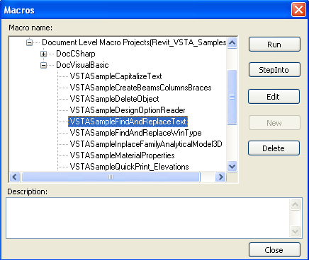
Figure 3: Revit VSTA Samples in VB.Net

Folder “GetTimeElapsedSinceLastSave”
Macro “GetTimeElapsedSinceLastSave” is an application-level macro, which is included in ThisApplication.cs (for C# user) or ThisApplication.vb (for VB.net user). This sample demonstrates a possible use of application level macros to monitor the Revit session for certain events, such as document save. Please merge ThisApplication.cs or ThisApplication.vb into your own application-level macro project to run this sample macro.

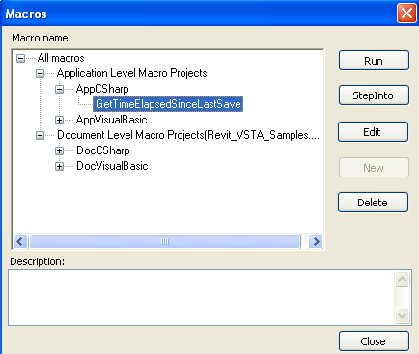
Figure 4: Application-level macro "GetTimeElapsedSinceLastSave" in C#
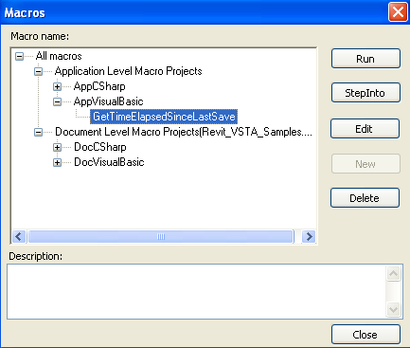
Figure 5: Application-level macro "GetTimeElapsedSinceLastSave" in VB.Net

Folder “Rooms”
This folder includes application-level “Rooms” macro related files. You can merge application-level “Rooms” macro into your own VSTA project according to instructions in the Revit VSTA User Manual. Note: A document-level version of the “Rooms” macro is contained in Revit_VSTA_Samples.rvt.

